Week 7-Supplier Database

**Create Database**

CREATE DATABASE Suppliers;

USE Suppliers;

**Create Tables**

CREATE TABLE Supplier(

sid INT PRIMARY KEY,

sname VARCHAR(30),

city VARCHAR(20)

);

CREATE TABLE Parts(

pid INT PRIMARY KEY,

pname VARCHAR(30),

color VARCHAR(20)

);

CREATE TABLE Catalog(

sid INT,

pid INT,

cost INT,

PRIMARY KEY(sid,pid),

FOREIGN KEY (sid) REFERENCES Supplier(sid),

FOREIGN KEY (pid) REFERENCES Parts(pid)

);

**Structure of the Tables:**

DESC Supplier;



DESC Parts;

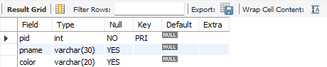

DESC Catalog;



**Inserting Values into the Tables:**

INSERT INTO Supplier(sid,sname,city) VALUES

(10001,"Acme Widget","Bangalore"),

(10002,"Johns","Kolkata"),

(10003,"Vimal","Mumbai"),

(10004,"Reliance","Delhi");

SELECT * FROM Supplier;

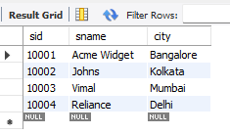

INSERT INTO Parts(pid,pname,color) VALUES

(20001,"Book","Red"),

(20002,"Pen","Red"),

(20003,"Pencil","Green"),

(20004,"Mobile","Green"),

(20005,"Charger","Black");

SELECT * FROM Parts;

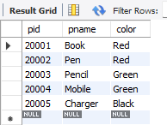

INSERT INTO Catalog(sid,pid,cost) VALUES

(10001,20001,10),

(10001,20002,10),

(10001,20003,30),

(10001,20004,10),

(10001,20005,10),

(10002,20001,10),

(10002,20002,20),

(10003,20003,30),

(10004,20003,40);

SELECT * FROM Catalog;

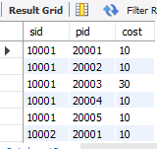

**Queries**

**Find the pnames of parts for which there is some supplier.**

SELECT DISTINCT pname

FROM Parts

WHERE pid IN(SELECT pid FROM Catalog);



**Find the snames of suppliers who supply every part.**

SELECT sname

FROM Supplier s

WHERE NOT EXISTS(SELECT pid FROM Parts WHERE pid NOT IN(SELECT c.pid FROM Catalog c WHERE c.sid=s.sid));



**Find the snames of suppliers who supply every red part.**

SELECT sname

FROM Supplier s

WHERE NOT EXISTS(SELECT pid FROM Parts WHERE color="Red" AND pid NOT IN(SELECT c.pid FROM Catalog c WHERE c.sid=s.sid));



SELECT pname

FROM Parts p

WHERE pid IN(SELECT pid FROM Catalog c WHERE c.sid=(SELECT sid FROM Supplier WHERE sname="Acme Widget")) AND pid NOT IN(SELECT pid FROM Catalog c WHERE c.sid!=(SELECT sid FROM Supplier WHERE sname="Acme Widget"));

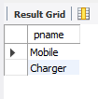

SELECT DISTINCT c.sid

FROM Catalog c

JOIN(SELECT pid, avg(cost) AS avg_cost FROM Catalog GROUP BY pid) a ON c.pid=a.pid WHERE c.cost>a.avg_cost;

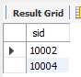

SELECT p.pid,s.sname

FROM Catalog c

JOIN Parts p ON c.pid=p.pid

JOIN Supplier s ON c.sid=s.sid

WHERE c.cost=(SELECT max(cost) FROM Catalog c2 WHERE c2.pid=c.pid);

